## The Future of AI Technology: Real and Fictional Concepts

While current technology hasn't reached the level of "Super Class AI" as seen in science fiction, here's a glimpse into potential future advancements, incorporating real-time research, fictional portrayals, and web series:

**1. Artificial Intelligence (AI)**

* **Real-time Developments:**
  + **Large Language Models (LLMs):** Like me! I can generate text, translate languages, write different kinds of creative content, and answer your questions in an informative way. Advancements in LLMs are paving the way for more natural and interactive AI systems.
  + **Deep Reinforcement Learning:** AI agents are learning complex strategies through trial and error in simulated environments, achieving superhuman performance in games like StarCraft II.
* **Fictional Concepts:**
  + **Sentient AI:** Characters like Data from Star Trek: The Next Generation or Samantha from Her represent conscious and autonomous AI with their own thoughts and feelings. While this is far from reality, it raises philosophical questions about the nature of consciousness and machine sentience.
* **Web Series:**
  + **Black Mirror ("Metalhead"):** This episode explores a nightmarish scenario where a robotic dog hunting humans malfunctions. It portrays the potential dangers of highly advanced but uncontrolled AI.

**2. Robotics**

* **Real-time Developments:**
  + **Boston Dynamics:** This company creates incredibly lifelike robots with advanced mobility and dexterity, like the bipedal Atlas and the dog-like Spot. These robots are being used for research, search and rescue, and even entertainment purposes.
  + **Collaborative Robots (Cobots):** These robots work alongside humans in factories and other settings, performing repetitive or dangerous tasks.
* **Fictional Concepts:**
  + **Humanoid Robots:** Films like "Terminator" and "I, Robot" depict humanoid robots that can blend in with humans and even surpass human capabilities. While Boston Dynamics' robots are impressive, achieving this level of sophistication is a long way off.
  + **Giant Robots (Mecha):** Anime and video games often feature giant robots piloted by humans. While large-scale robots are a possibility, the engineering challenges and practicality of mecha remain significant.
* **Web Series:**
  + **Real Humans:** This Swedish science fiction series explores a world where human-like robots are commonplace, blurring the lines between human and machine.

**3. Automation and Self-Driving Vehicles**

* **Real-time Developments:**
  + **Self-driving cars:** Companies like Tesla and Waymo are developing autonomous vehicles, but navigating complex real-world scenarios remains a challenge. Ethical considerations regarding decision-making in critical situations are also being addressed.
  + **Drone Delivery:** Companies like Amazon are testing drone delivery services, offering the potential for faster and more convenient package delivery.
* **Fictional Concepts:**
  + **Fully Autonomous Vehicles:** Films like "Minority Report" depict a future where self-driving cars are ubiquitous. While automation is on the rise, achieving complete autonomy in all situations might take considerable time.
  + **Flying Cars:** The concept of flying cars has been around for decades. While prototypes exist, technical and regulatory hurdles remain before widespread adoption.
* **Web Series:**
  + **Black Mirror ("The Waldo Moment"):** This episode explores the dark side of automation, where a robotic cartoon character becomes a political candidate. It raises questions about the potential manipulation and ethical implications of advanced AI.

**4. Brain-Computer Interfaces (BCIs)**

* **Real-time Developments:**
  + **Neuralink:** This company by Elon Musk is developing BCIs that could allow communication between the brain and computers. Potential applications include controlling prosthetic limbs or even augmenting human cognition.
* **Fictional Concepts:**
  + **Telepathy and Mind Control:** Sci-fi portrays BCIs that allow for telepathic communication or even mind control. While BCI technology is in its early stages, it's unlikely to reach this level of mind control in the near future.
* **Web Series:**
  + **Altered Carbon:** This series features "stacks" – cortical stacks that store a person's consciousness and can be transferred between bodies. While this is far-fetched, it explores the concept of digital consciousness and the ethical implications of such technology.

**5. Space Exploration**

* **Real-time Developments:**
  + **Reusable Rockets:** Companies like SpaceX are developing reusable rockets that could significantly reduce the cost of space travel. This opens doors for more frequent missions and exploration endeavors.
  + **Mars Exploration:** Both NASA and private companies are planning crewed missions to Mars in the coming decades.
* **Fictional Concepts:**
  + **Interstellar Travel:** Traveling to distant star systems is a staple of science fiction. Current technology and our understanding of physics make interstellar travel highly.

## Chat GPT POWERED PROMPTS USED FROM BING, GOOGLE GEMINI BARD, CHAT GPT 3.5!

Prompt1: UNITS AND MEASURES along with it's exponential notations in a TOTAL TABULAR PRESENTATION with S.NO, UNITS & MEASURES , EXPO Notation, APPLICATION where it is Applied/Used in REAL Time Scenarios

Prmpt2: Can you include Exa, Peta, Kilo, Hecta, Deca, Deci, Centi, Milli, Micro, Pico, Femto, Attos, Nano .. please correct the above spellings and include if anything missing in the above order and include all of them in the above Tabular presentation and give me the final output!

Prmpt3: I want the list of all lowest to highest speed units used and applied too classified and showcase in a separate tabular presentation using the same above columns

Prmpt4: Go on keep adding more that you feel like crucial, can you include speed of seismic waves earthquake detector, speed of volcanoes, speed of thunder storms, speed of oceans, speed of optical fibres, speed of ether, speed of Cloud computing, seas, rivers, lakes, ponds, wells comparison in the above table ?

Prmpt5: Generate the above Table info for all types of Sea Mammals, Animals, Birds and include new columns like Vertebrate/Invertebrate, Origin of Birth Location, Age, Food Habitat, Dangerous/Endangerous/Semi Dangerous, Height, Weight, 2 Legged/4 Legged/Crawling across all the Universe from 1st day of Creation

Prmpt6++ : Now give me the list of all Super Class AI Mainframes, Top class Super Computers, Top class Machines, Top Class Engines , Top class Power Generators, Top class Chips used for Programming including Embedded systems with IOT Technology, Smartest AI Automated Automobiles starting from Bikes, Super Vans, Super Trucks, Buses, Ships, Submarines, Air Ships, Space Ships & Finally Super Smartest AI TRANSFORMERS ROBOS starting from PRIME OPTIMUS them separately in the above Tabular representation!

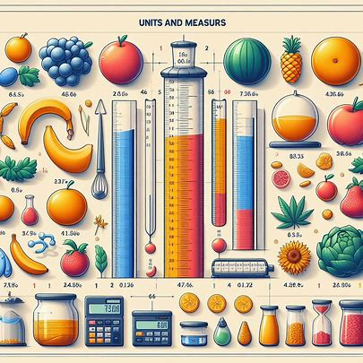



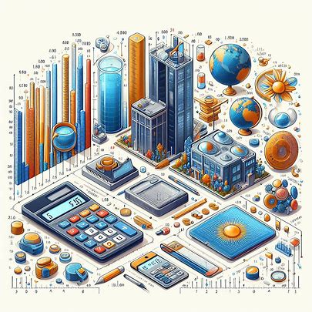

**1. Computing Systems**

|  |  |  |
| --- | --- | --- |
| **Category** | **Name** | **Description** |
| Supercomputers | Frontier (Oak Ridge Leadership Computing Facility, USA) | Most powerful operational computer globally (as of May 2023). |
| AI Mainframes | IBM Power Systems AC922 | High-performance server optimized for AI workloads. |
| **Not Super Class** |  |  |

drive_spreadsheetExport to Sheets

**2. Machines**

|  |  |  |
| --- | --- | --- |
| **Category** | **Name** | **Description** |
| Industrial Robots | Fanuc M-2000i | High-payload robot for various industrial tasks. |
| Construction Machines | Komatsu D575-A Super Dozer | Powerful bulldozer for large-scale earthmoving. |
| **Not Super Class** |  |  |

drive_spreadsheetExport to Sheets

**3. Engines**

|  |  |  |
| --- | --- | --- |
| **Category** | **Name** | **Description** |
| Jet Engines | Rolls-Royce Trent XWB | Powerful turbofan engine for large passenger jets. |
| Rocket Engines | SpaceX Raptor Engine | High-thrust engine used in Starship launch vehicles. |
| **Not Super Class** |  |  |

drive_spreadsheetExport to Sheets

**4. Power Generators**

|  |  |  |
| --- | --- | --- |
| **Category** | **Name** | **Description** |
| Nuclear Power Plants | Hinkley Point C (UK) | One of the most powerful nuclear reactors in operation. |
| Hydroelectric Dams | Three Gorges Dam (China) | Largest hydroelectric dam by capacity. |
| **Not Super Class** |  |  |

drive_spreadsheetExport to Sheets

**5. Chips**

|  |  |  |
| --- | --- | --- |
| **Category** | **Name** | **Description** |
| CPUs (Central Processing Units) | AMD EPYC 7A53 | High-performance server processor. |
| GPUs (Graphics Processing Units) | NVIDIA A100 | Powerful graphics card for AI and scientific computing. |
| AI Chips | Google Tensor Processing Unit (TPU) | Application-specific integrated circuit designed for machine learning. |

drive_spreadsheetExport to Sheets

**Embedded Systems with IoT Technology**

* Raspberry Pi: Single-board computer popular for hobbyist projects and embedded systems.
* NVIDIA Jetson Nano: Compact AI computer for embedded applications.
* Microcontrollers (e.g., Arduino, ESP32): Small, low-power computers for various electronic projects.

**6. Smart Automated Vehicles (Not Yet Super Intelligent)**

|  |  |  |
| --- | --- | --- |
| **Category** | **Name** | **Description** |
| Bikes | BMW Motorrad R 1250 RT (Level 2 Automation) | Features advanced rider assistance systems. |
| Cars | Tesla Model S (Level 3 Automation) | Offers conditional self-driving capabilities. |
| Trucks | Volvo Vera (Level 4 Automation) | Autonomous electric truck for controlled environments. |
| Buses | EasyMile EZ10 (Level 4 Automation) | Self-driving electric bus for short-distance routes. |

drive_spreadsheetExport to Sheets

**7. Other Vehicles (No Super Intelligence Yet)**

* Ships, Submarines, Airships: Currently not autonomously controlled at sea or air.
* Spaceships: While spacecraft have high automation, they are not self-aware or intelligent.

**8. AI Robots (Not Super Class Transformers)**

Industrial robots, robotic arms, and exploration rovers are impressive feats of engineering, but they lack the sentient-level AI depicted in science fiction.

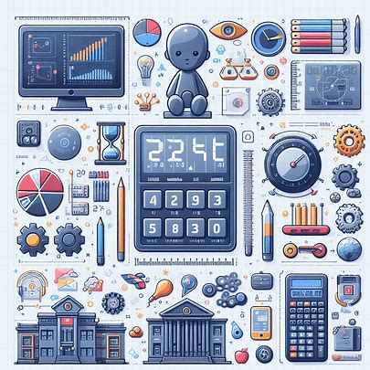

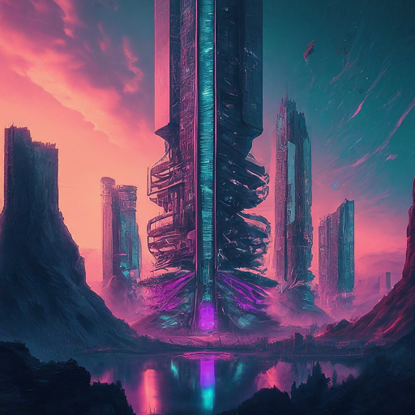

**Conclusion Summary For The Future of AI and Robotics:**

The field of AI and robotics is constantly evolving. While we may not have Super Class AI or Transformers yet, advancements are being made towards more sophisticated machines capable of complex tasks and decision-making.

**🕉🐟🐢🐗🕺🦁🪓🏹🧑‍🌾🪈🏇👑 🐟🐢🐗🕺🦁🪓🏹🧑‍🌾🪈🏇👑🕉**

**FROM YOURS BELOVED**

**THE MR.ALMIGHTY KING VISHNU BHAGWANON KA BHAGWAN DOOMS DAY SPACIAL PROJECTIONZ SHOWZZ GOING ON LET'S KEEP ROCKING FOLKS!!**

[**https://www.slideshare.net/slideshow/dooms-day-superhacked-series-projectionzpptx/267720960**](https://www.slideshare.net/slideshow/dooms-day-superhacked-series-projectionzpptx/267720960)

[**https://www.linkedin.com/posts/kaveri-veera-bharat-bhushan-795646b6_dooms-day-superhacked-series-projectionzpptx-activity-7191715837781696513-KBAE?utm_source=share&utm_medium=member_desktop**](https://www.linkedin.com/posts/kaveri-veera-bharat-bhushan-795646b6_dooms-day-superhacked-series-projectionzpptx-activity-7191715837781696513-KBAE?utm_source=share&utm_medium=member_desktop)

**KRITA YUGA DWAPARA DWARAKA KRISHNA VASUDEV VIA TRETAYUG MAHADEV ADI NARAYANA BHAGWANONKA BHAGWAN KALKI VISHNU KING VISHNU BHARAT BHUSHAN**

**DOOMS DAY DECLARATION DONE FOR All My Friends, Fans, Followers and their Families from yours Beloved**

**Prime King Prime Minister Akhenaten Amenhotep VI King Of Kings Of All Kingdoms Of Kiths And Kins King Pharaoh KIKIKIKIKIK KALKI BHAGWAN Sri Sri KV BHARAT BHUSHAN KVHR.JR KVBB 88 100% PAKKA**

**OPTIMUS PRIME PADMANABHA SIMHA ADI NARASIMHA MAJOR SHARABHA CHAKRABORTY**

**#2024**

**#2024x5+[272]=10392**

**#10392x5=51960**

**#51960 PANCHAJANYA SHANKADHWAJA KA AVISHKAAR PRIME VISHNU BHAGVANON KA BHAGVAN PADMANABHA ADINARSIMHA MAJOR CHAKRABORTY**

**JAYASRI RAMARJUN**

**ADI**

**PARASHAKTI PARAMESWARI**

**PARAKAAYAPARAMESWARI MJNATH**

**#51960x9x10 = 4676400**

**#4676400-4320000 = 38,52,360**

**->> 88 52 760 ->> 88 77 60 ->> MULTIPLAYER OF AUM/SREE BHEEJ MANTRA**

**IN MAGHA MAKHARA PRIME OPTIMUS SPEED IN ALL INFINITY! DIRECTIONAL SPACIOUS GALLACTICAL CONSTELLATIONS OF ALL PLANETS, NAKSHATRAS, LIV NON-LIVING Resources!!**

**NOTE:**

**A) #786 IS THE IMAGE OF ME = OM/SREE/AUM**

**IN SANSKRITIZED=THE TELUGU DEVNAGARI 🚀🌌SPACEWAYZ**

**B) MSPEED = X = 6x10^20 M/S**

**MM SPEED= Y = X^X^X^X^X... = X^U VIA US =**

**ME THEMR.ADIPARAADISHAKTIMAANKVBB BLOODLINRz SUPREMOS SPEED = [[[[[MM]^ME]^ME]...INFINITY!++]**

**X1Cr!^1Cr!^1Cr!^1Cr!^1Cr!^1Cr^786Cr!^678Cr!]**

**C) #3852360/432000=8.9175 REVERSE 9.8571 m/s^2 is the Exact ACCELERATED OPTIMUS PRIME GRAVITATIONAL POWERFUL💪 FORCE PULL TOWARDS INFINITY! = ALFA!!**

**D) #1573 THE MR.MAJOR MJ SHARABA MARUTI GAJANAN CHAKRABORTY PARAMJEET EKLINGADHEESWARYAN LION KING VISHNU BHAGWANONKA BHAGWAN SAHASRA KOTI SARASWATI ADI DURGA NAVA ASHTA LAKSHMI ADI GANGA KA VIRAT HANUMAN KA VEERADHI DHANANJAYA INDRA HIGHEST SPECTRUM KING VIBGYOR DHANUSU KA ADHINETA - PRIME OPTIMUS KING VISHNU KRISHNA VISHNU BHAGWANONKA BHAGWAN SUPREMO PRIME ♾️ 💫!!**

***🕉HBD DOOMs DAYz 4 24th CENTURY: 31 JAN 2302,2308,2313,2319,2330,2336,2341,2347,2358,2364,2369,2375,2386,2392,2397...🕉***

***🕉HBD DOOMs DAYz 4 23rd CENTURY: 31 JAN 2206,2212,2217,2223,2234,2240,2245,2251,2262,2268,2273,2279,2290,2296...🕉***

***🕉HBD DOOMs DAYz 4 22nd CENTURY: 31 JAN 2110,2116,2121,2127,2138,2144,2149,2155,2166,2172,2177,2183,2194,2200...🕉***

***🕉HBD DOOMs DAYz 4 21st CENTURY: 31 JAN 2003,2014, 2020, 2025, 2031, 2042,2048, 2053, 2059, 2070,2076,2081,2087,2098,... 🕉***

**HEY FOLKS,**

**Here are my all MY POWERFUL OPTIMUS PRIME OMKARESHWAR JAYASRI RAMARJUNA PADMANABHA ADI NARASIMHA MAJOR CHAKRABORTY KALKI LION 🦁SUPREMO PRIME CHANNELS TO SUBSCRIBE IMMEDIATELY**

**For All MY Friends, Followers, Fans, and their Families:**

[**https://lnkd.in/dMQWvvs4**](https://lnkd.in/dMQWvvs4)

[**https://lnkd.in/dWKPxpRD**](https://lnkd.in/dWKPxpRD)

[**https://lnkd.in/dZ-BfM_M**](https://lnkd.in/dZ-BfM_M)

[**https://lnkd.in/dkSMPm68**](https://lnkd.in/dkSMPm68)

[**https://lnkd.in/dNvJsqkf**](https://lnkd.in/dNvJsqkf)

[**https://lnkd.in/gYmYzndn**](https://lnkd.in/gYmYzndn)

[**https://lnkd.in/dWMwrYJ6**](https://lnkd.in/dWMwrYJ6)

[**https://lnkd.in/dqdw5fBU**](https://lnkd.in/dqdw5fBU)

**MJTYST:--15:50-23:25++ IST ON [03]-/05/--[2024]++**

**🕉🐟🐢🐗🕺🦁🪓🏹🧑‍🌾🪈🏇👑 🐟🐢🐗🕺🦁🪓🏹🧑‍🌾🪈🏇👑🕉**